1. Auto Refresh/Auto Reloading:- It is HttpProtocol feature. This feature related method is available only in HttpServletResponse Class. This feature related method is not in ServletResponse class.

The method is

setHeader(“refresh”,”seconds”);

The servlet component send instruction to browser through res obj, container, web-server to refresh/reload the web page automatically for every specified seconds.

This feature is use-full in following use-cases:

1. While displaying live-game scores.
2. While displaying stock-values.
3. While displaying weather.

Example:-

Step1:

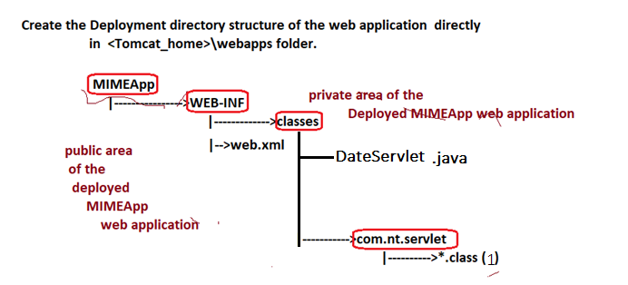

Step 2:- Develop the source of DateServlet component.

package com.nt.servlet;

import java.io.\*;

import jakarta.servlet.\*;

import jakarta.servlet.http.\*;

import java.util.Date;

public class DateServlet extends HttpServlet{

protected void service(HttpServletRequest req, HttpServletResponse res)throws ServletException,IOException{

res.setContentType("text/html");

PrintWriter pw=res.getWriter();

Date d=new Date();

res.setHeader("refresh","05");

pw.println("<h2 align='center'>Date is:"+d+"</h2>");

pw.close();

}

}

Step3: configure servlet component in web.xml file.

<web-app>

<servlet>

<servlet-name>date</servlet-name>

<servlet-class>com.nt.servlet.DateServlet</servlet-class>

</servlet>

<servlet-mapping>

<servlet-name>date</servlet-name>

<url-pattern>/date</url-pattern>

</servlet-mapping>

</web-app>

Step4:-

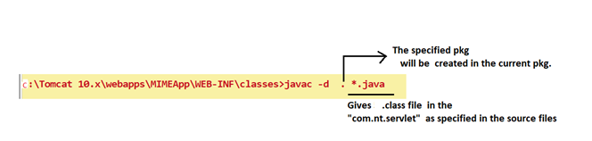

Step5: start the server and test Application from Browser.

